Special Circumstance

Skip-A-Payment Application, Disclosure, and Agreement

Yes! I want to take advantage of the WCSEFCU Skip-A-Payment Program.
I have read and agreed to the terms below.

DATE |  | ACCOUNT # | Borrower (s):
FEE PAYMENT WAIVED – State of Emergency Skip
LOAN # | AMOUNT: |  |  | MONTHS OF PAYMENT TO SKIP (up to 2):
Briefly describe reason for request:
By signing below, I/we request to skip the payment referenced above. * I/we agree to all the provisions of the Skip-A-Payment program as described in this disclosure.
BORROWER’S SIGNATURE |  |  |  |  | DATE
JOINT BORROWER’S SIGNATURE |  |  |  |  | DATE
*For qualified members. One skip per loan (up to three loans per member) permitted per calendar year. Cannot be used to repair delinquency. Please note: By skipping your loan payment for 1-2 months, you authorize Ware County School Employees Federal Credit Union to extend your final loan payment. Finance charges will continue to accrue on your unpaid balance. Your account must be in good standing to take advantage of this offer. The credit union reserves the right to determine if prior subsequent actions may disqualify your loan.

**A separate written Application, Disclosure, and Agreement must be completed and submitted for each loan on which the borrower(s) want(s) to apply to skip a payment. Submitting this application does not guarantee your skip a payment is approved.

Other restrictions may apply. You may fax the application, mail to our office, or e-mail it to one of our staff members.

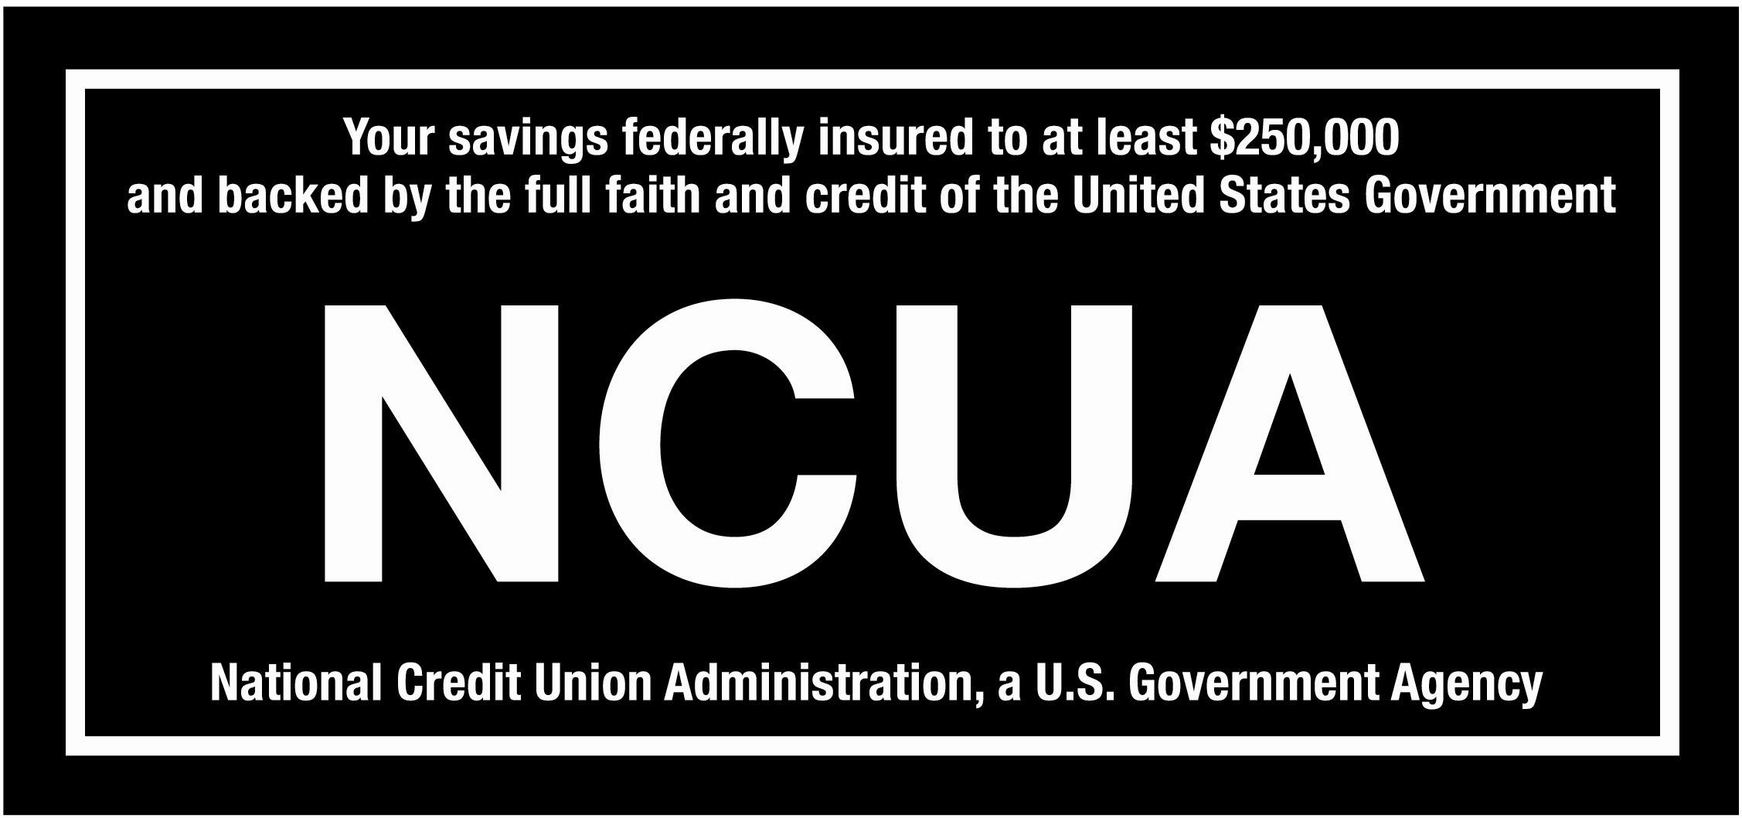
We do business in accordance with the Federal Fair Housing Law and Equal Opportunity Act.

